RAGILESH O K
ONIVAYAL KUNIYIL HOUSE MUTTUNGAL-P.O VATAKARA-VIA CALICUT-673106 KERALA-INDIA PH:0496-2521314
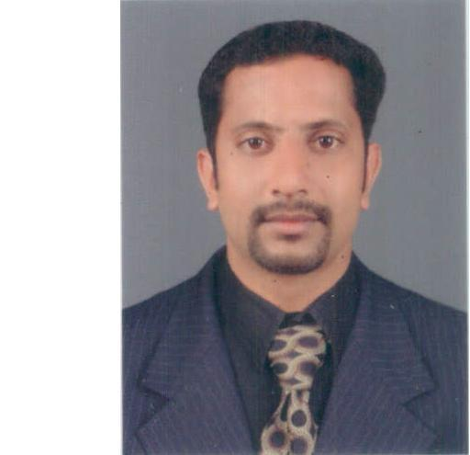

MOB: 9747305859
Email: ragileshok@gmail.com

OBJECTIVE:

Joining a professionally managed and dynamic organization, this provide opportunities for self-development and responsibilities to contribute towards organization success.

PROFILE:

- Customer acquisition through new potential leads of NRI's, CA, SA.

- Achieve the branch targets and make branch profit through CA, Fee Income, Quality Products

- Skilled with all aspects of sales and Marketing Process

- Well developed communication, negotiation, Personnel and team management abilities

- Highly motivated, energetic, positive team player with a “roll-up the sleeves attitude.

PERSONEL DETAILS

Age and DOB: 30, 23-05-1984
Sex: Male
Marital status: Married

QUALIFICATION

BCOM Graduation from University of Calicut (2005)

WORK EXPERIENCE:

- Four years experience for Senior Assistant in Accounts at Kerala State Electricity Board -Parat (Kannur Dt.) from 01-09-2006 to 31-01-2010

Profile Description: Handle bills and prepare monthly accounts.

- Currently working as a Junior Officer in ICICI Bank Limited Nadapuram Branch (Calicut Dt.) as on 20-09-2010
Nature of work:

- Account Opening

- FD Account opening.

- Deposits of Advances

- Welcome desk Operation

- Gold Loans handling

- Customer Service

- Contact new customers for New A/c, FD, s & Loans.

DUTIES AND RESPONSIBILITIES

- Currently taking care of sales operations

- Developing a compliance culture in Branch

- Review and Monitor AOF rejection Cases, Account Closure, Fixed deposits etc.

- Assets Servicing Proper Authorization of KYC documents

- Co ordination of operation and sales

- Focus on Branch profitability

- Maintain good infrastructure / Good Customer Quality Score

ACHIEVEMENT

- Achieved FD RATNA Contest for FD

- Achieve PMS rating-1 in the year 2011-12

- Award of Excellence in Star of South-Nov2013

- Award of Excellence in Star of South-Dec2013

- Zonal Achievers Conclave Q1 Q2 Q3 Q4 -2013

REFERENCES

SUNIL VP
Deputy Branch Manager
ICICI Bank Ltd
Perambra
Mob: 9605505555

LANGUAGES KNOWN (READ, WRITE, SPEAK)

MALAYALAM, ENGLISH

DECLARATION

All the information above said particulars are true to the best of my knowledge and belief.

Place:Vadakara
Date: 31/10/14
Ragilesh OK

